250030264_LAXMI SRI
WEEK-2 PRACTICAL DATABASE SYSTEM ENGINEERING

Step 1 — Create Database CREATE DATABASE bookflow_db; USE bookflow_db;

output:
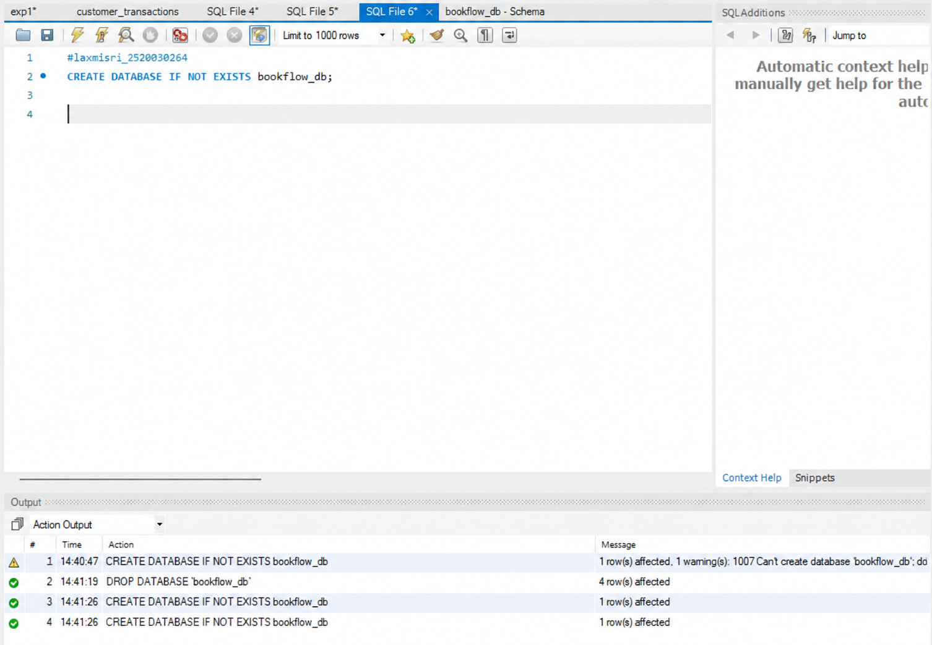
Step 2 — Create Books Table (DDL + Constraints) CREATE TABLE Books ( book_id INT PRIMARY KEY, title VARCHAR(100) NOT NULL, isbn VARCHAR(20) UNIQUE, published_year INT CHECK (published_year < 2027) );

output:

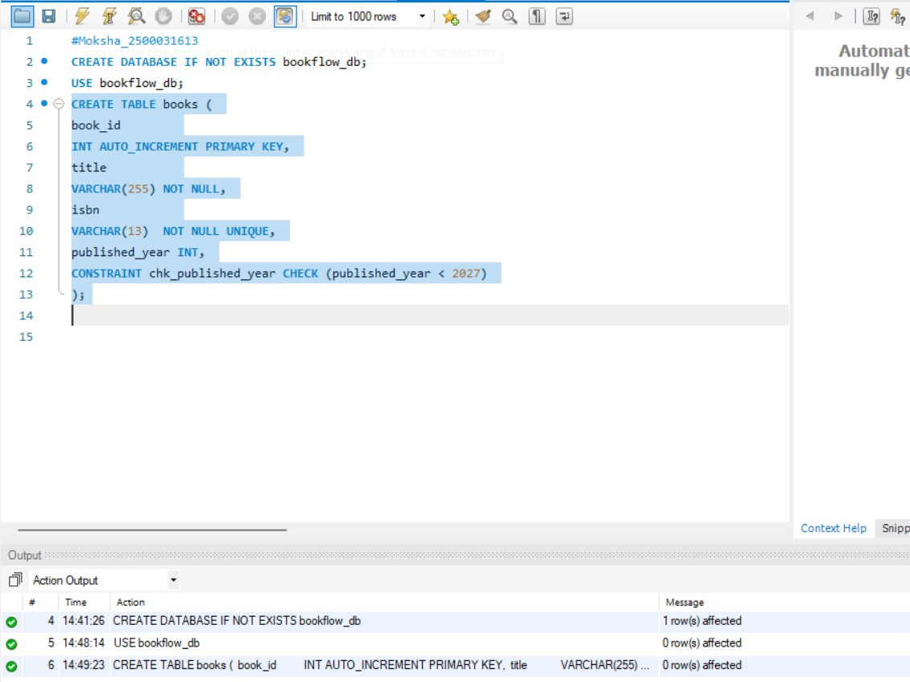
Step 3 & 4 — Insert Books and Display INSERT INTO Books (book_id, title, isbn, published_year) VALUES (1, 'The Great Gatsby', '9780743273565', 1925), (2, 'To Kill a Mockingbird',
'9780061120084', 1960), (3, '1984', '9780451524935', 1949); SELECT * FROM Books;

output:

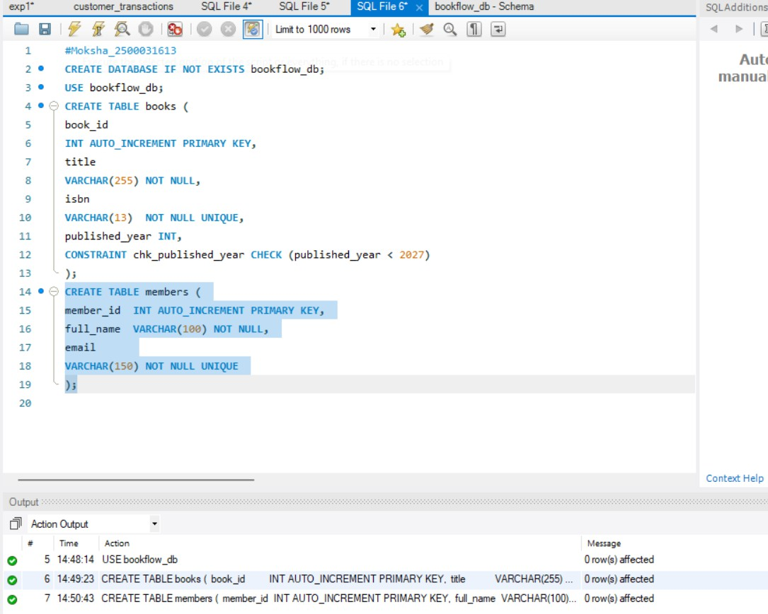

step 5, 6 & 7 — Members Table: Create, Insert, Display CREATE TABLE Members ( member_id INT PRIMARY KEY, full_name VARCHAR(100), email VARCHAR(100) UNIQUE ); INSERT INTO
Members (member_id, full_name, email) VALUES (101, 'John Smith', 'john.smith@email.com'), (102, 'Emma Wilson', 'emma.wilson@email.com'), (103, 'Michael Brown', 'michaelS.brown@email.com'); SELECT * FROM Members;
output:

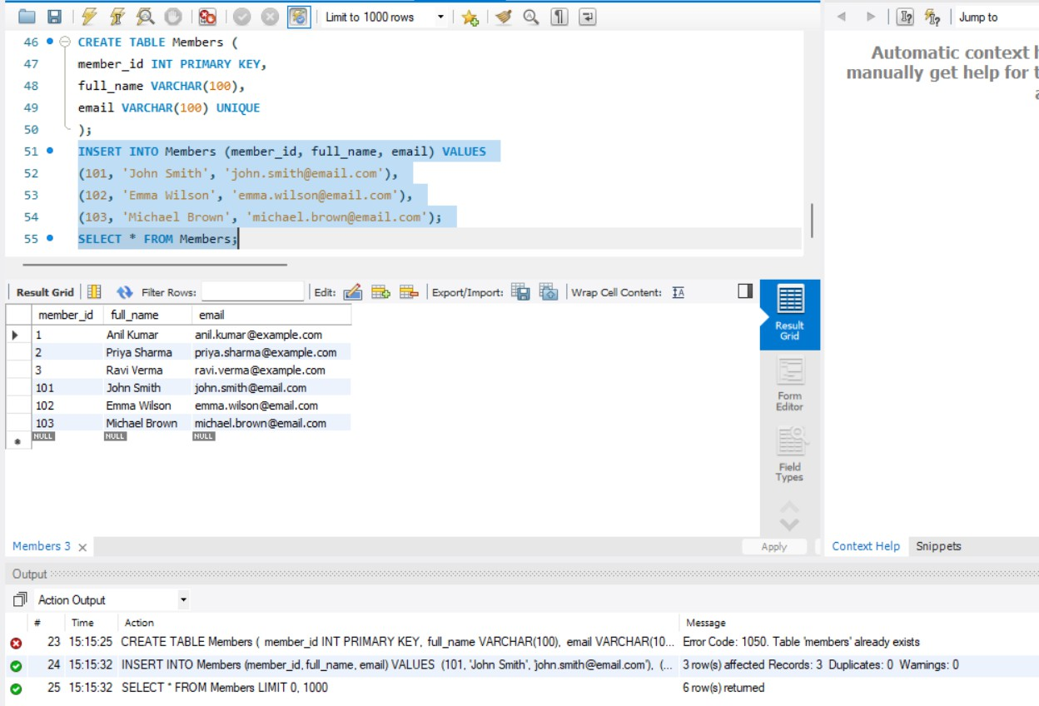
Step 8 — Create Loans Table (FOREIGN KEYS) CREATE TABLE Loans ( loan_id INT PRIMARY KEY, member_id INT, book_id INT, loan_date DATE, FOREIGN KEY (member_id) REFERENCES Members(member_id), FOREIGN KEY (book_id) REFERENCES Books(book_id) );

output:

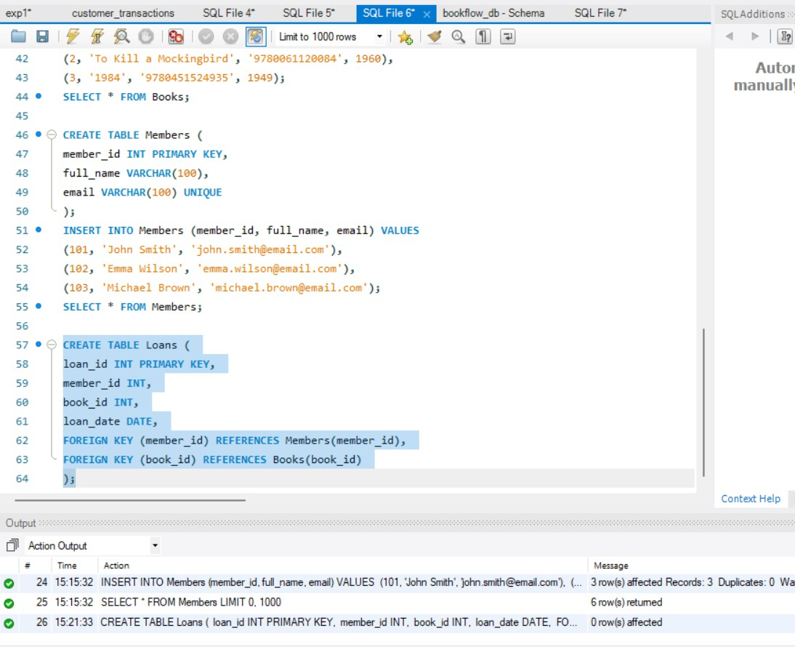
Step 9 & 10 — Insert 10 Loans and Display INSERT INTO Loans (loan_id, member_id, book_id, loan_date) VALUES (1, 101, 1, '2025-
01-05'), (2, 102, 2, '2025-01-08'), (3, 103, 3, '2025-01-10'), (4, 101, 2,
'2025-02-01'), (5, 102, 1, '2025-02-05'), (6, 103, 2, '2025-02-12'), (7,
101, 3, '2025-03-01'), (8, 102, 3, '2025-03-07'), (9, 103, 1, '2025-03-
15'), (10, 101, 1, '2025-04-01'); SELECT * FROM Loans;

output:

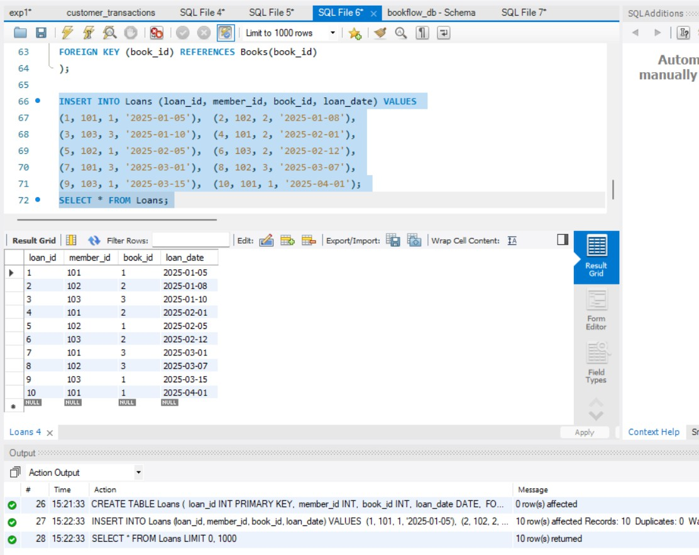
Step 11 — JOIN Query (Who Borrowed What) SELECT m.full_name AS Member_Name, b.title AS Book_Title FROM Loans l INNER JOIN Members m ON l.member_id = m.member_id INNER JOIN Books b ON l.book_id = b.book_id;

output:

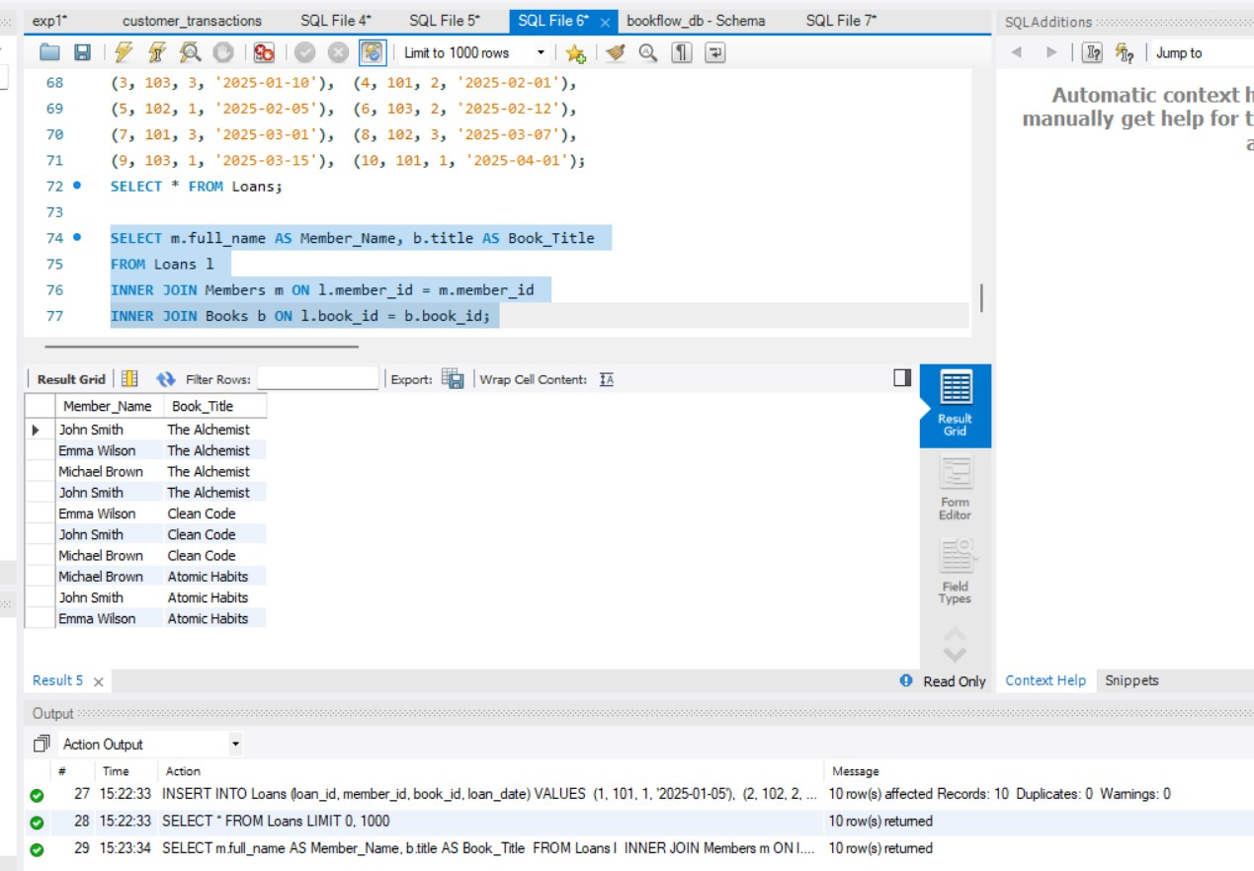
Step 12 — GROUP BY Query (Books per Year) SELECT published_year, COUNT(book_id) AS Total_Books FROM Books GROUP BY published_year ORDER BY published_year;

output:

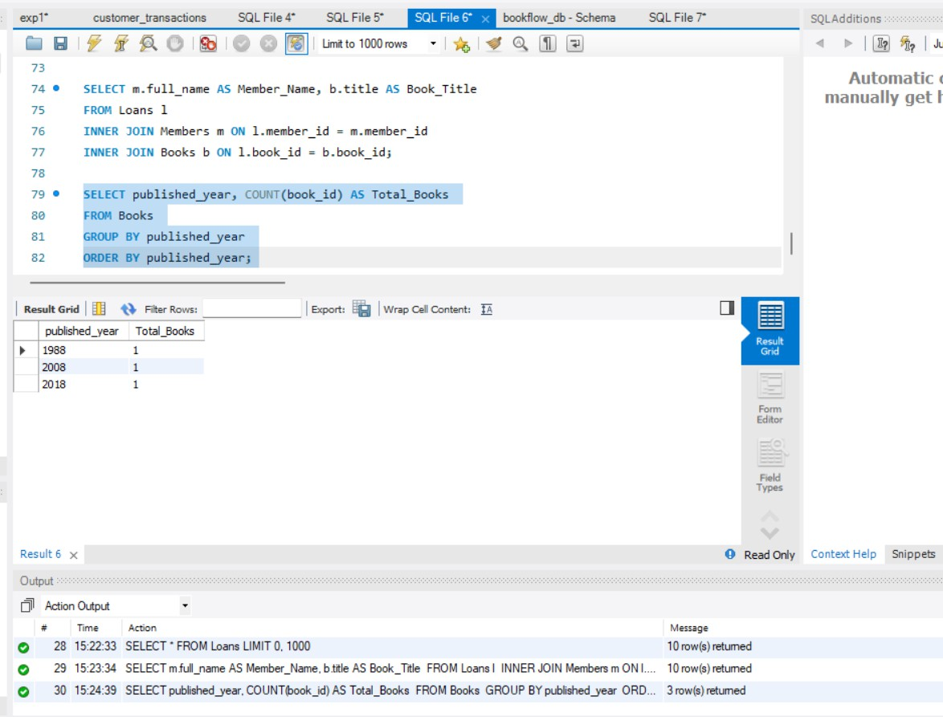
Step 13–16 — Donation via TRANSACTION (Atomicity) CREATE TABLE Donation_History ( donation_id INT PRIMARY KEY, book_id INT, donor_name VARCHAR(100), donation_date DATE, FOREIGN KEY (book_id) REFERENCES Books(book_id) ); START TRANSACTION; INSERT INTO Books (book_id, title, isbn, published_year) VALUES (4, 'Animal Farm', '9780451526342', 1945); INSERT INTO Donation_History (donation_id, book_id, donor_name, donation_date) VALUES (1, 4, 'Raj Kumar', CURDATE()); COMMIT;
output:

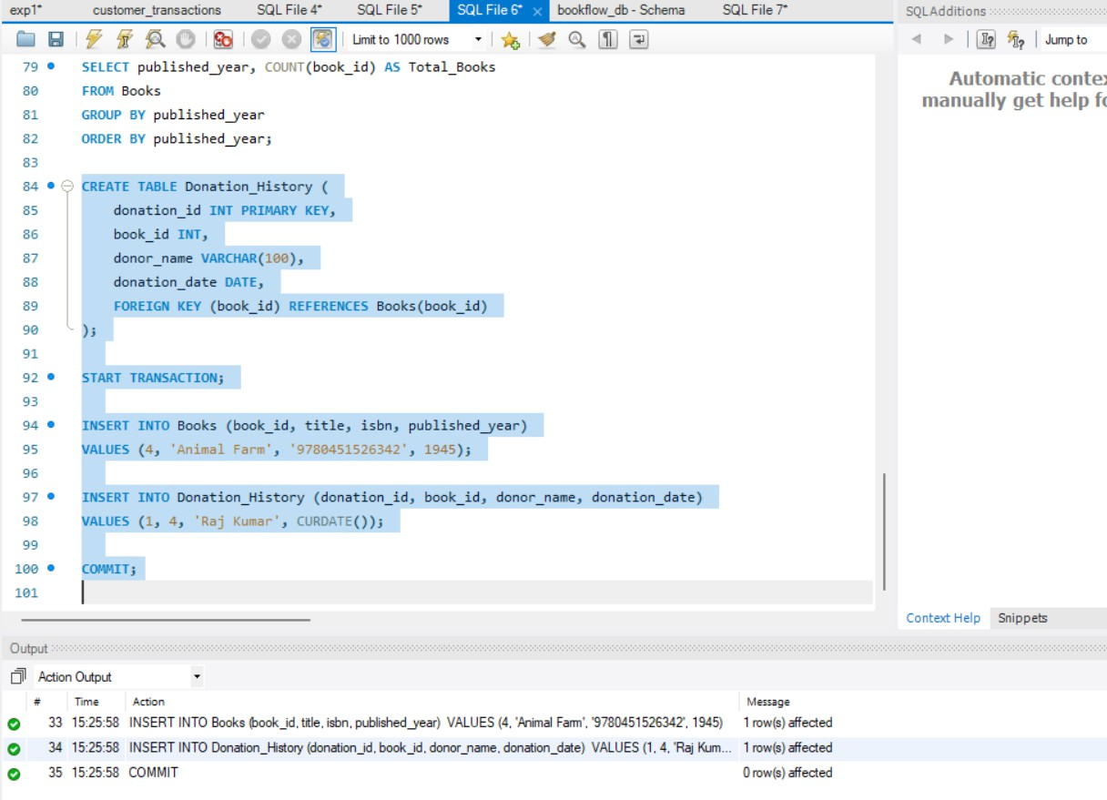
Step 17 & 18 — Index on ISBN + Fast Search CREATE INDEX idx_books_isbn ON Books(isbn); SELECT * FROM Books WHERE isbn = '9780451524935';
output:

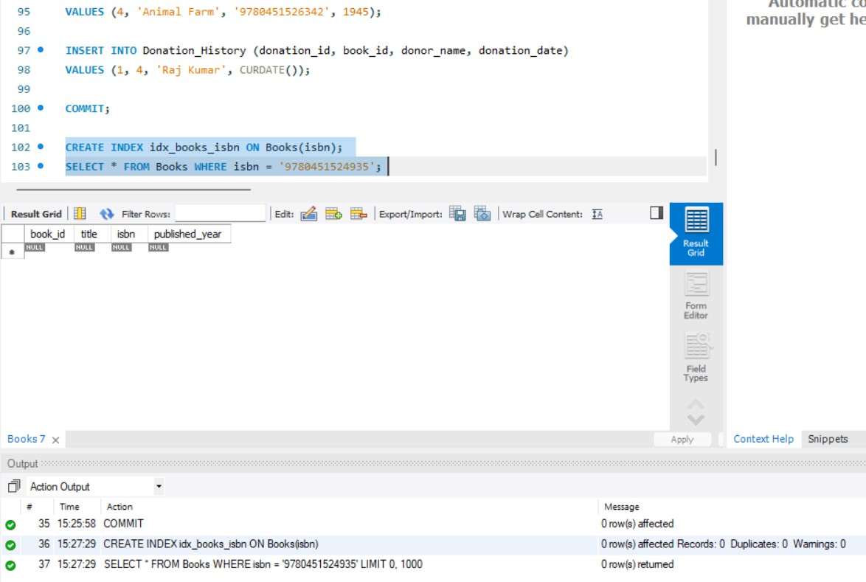

Assignments
Problem Statement 1: SkyTrack Airline Management System A regional airline company currently manages its flight schedules, passenger records, and ticket bookings using spreadsheets. As the number of flights and passengers continues to grow, it has become difficult to track reservations, maintain accurate records, and generate operational reports. To improve efficiency, the airline plans to develop a database system called SkyTrack. As a database developer, your task is to create a database named skytrack_db and design three tables: Flights, Passengers, and Bookings. The Flights table should contain details such as flight_id, flight_number, source, destination, departure_date, and ticket_price, while the Passengers table should store passenger_id, passenger_name, and email. The Bookings table should connect passengers and flights using passenger_id and flight_id as foreign keys. Apply appropriate constraints, including PRIMARY KEY, UNIQUE, and CHECK constraints to ensure data integrity. Insert at least 10 records into each table. Display all table contents and write an SQL query using INNER JOIN to show the passenger name, flight number, source, and

destination for every booking. Generate a report showing the total number of flights operating to each destination using COUNT() and GROUP BY. Create a Flight_History table and demonstrate the use of a Transaction by adding a new flight and simultaneously recording the entry in the history table, ensuring both operations succeed or fail together. Finally, create an Index on the flight_number column and explain why searching by flight number is faster than searching by destination. This exercise develops skills in relational database design, JOIN operations, aggregate functions, transactions, and indexing.
output:CREATE DATABASE skytrack_db; USE skytrack_db;

-- 1. Flights Table CREATE TABLE Flights (
flight_id INT PRIMARY KEY,
flight_number VARCHAR(20) UNIQUE NOT NULL, source VARCHAR(50) NOT NULL,
destination VARCHAR(50) NOT NULL, departure_date DATE NOT NULL,
ticket_price DECIMAL(10,2) CHECK (ticket_price > 0)
);

-- 2. Passengers Table CREATE TABLE Passengers (
passenger_id INT PRIMARY KEY, passenger_name VARCHAR(100) NOT NULL, email VARCHAR(100) UNIQUE NOT NULL

);

-- 3. Bookings Table CREATE TABLE Bookings (
booking_id INT PRIMARY KEY, passenger_id INT NOT NULL, flight_id INT NOT NULL, booking_date DATE NOT NULL,
FOREIGN KEY (passenger_id) REFERENCES Passengers(passenger_id), FOREIGN KEY (flight_id) REFERENCES Flights(flight_id)
);

-- Insert 10 Flights
INSERT INTO Flights VALUES
(1, 'ST101', 'Hyderabad', 'Delhi', '2026-09-01', 5500),
(2, 'ST102', 'Hyderabad', 'Mumbai', '2026-09-02', 4500),
(3, 'ST103', 'Chennai', 'Bangalore', '2026-09-03', 3000),
(4, 'ST104', 'Delhi', 'Kolkata', '2026-09-04', 6000),
(5, 'ST105', 'Mumbai', 'Goa', '2026-09-05', 3500),
(6, 'ST106', 'Bangalore', 'Delhi', '2026-09-06', 5200),
(7, 'ST107', 'Chennai', 'Hyderabad', '2026-09-07', 4000),
(8, 'ST108', 'Kolkata', 'Mumbai', '2026-09-08', 5800),
(9, 'ST109', 'Delhi', 'Bangalore', '2026-09-09', 5000),
(10, 'ST110', 'Hyderabad', 'Goa', '2026-09-10', 4200);

-- Insert 10 Passengers
INSERT INTO Passengers VALUES
(1, 'Chaitanya Kiran', 'chaitanya@gmail.com'), (2, 'Rahul Sharma', 'rahul@gmail.com'),
(3, 'Priya Reddy', 'priya@gmail.com'), (4, 'Arjun Kumar', 'arjun@gmail.com'), (5, 'Sneha Rao', 'sneha@gmail.com'),
(6, 'Vikram Singh', 'vikram@gmail.com'), (7, 'Ananya Das', 'ananya@gmail.com'), (8, 'Kiran Patel', 'kiran@gmail.com'),
(9, 'Meghana Devi', 'meghana@gmail.com'), (10, 'Rohit Verma', 'rohit@gmail.com');

-- Insert 10 Bookings
INSERT INTO Bookings VALUES (1, 1, 1, '2026-08-17'),
(2, 2, 2, '2026-08-17'),
(3, 3, 3, '2026-08-17'),
(4, 4, 4, '2026-08-18'),
(5, 5, 5, '2026-08-18'),
(6, 6, 6, '2026-08-18'),
(7, 7, 7, '2026-08-19'),
(8, 8, 8, '2026-08-19'),

(9, 9, 9, '2026-08-19'),
(10, 10, 10, '2026-08-20');

-- Display all tables SELECT * FROM Flights;
SELECT * FROM Passengers; SELECT * FROM Bookings;

-- INNER JOIN: Passenger + Flight details SELECT
p.passenger_name, f.flight_number, f.source, f.destination
FROM Bookings b
INNER JOIN Passengers p
ON b.passenger_id = p.passenger_id INNER JOIN Flights f
ON b.flight_id = f.flight_id;

-- Number of flights operating to each destination SELECT
destination,
COUNT(*) AS total_flights

FROM Flights
GROUP BY destination;

-- Flight History Table
CREATE TABLE Flight_History (
history_id INT PRIMARY KEY AUTO_INCREMENT,
flight_id INT NOT NULL,
flight_number VARCHAR(20) NOT NULL, action VARCHAR(50) NOT NULL,
action_date TIMESTAMP DEFAULT CURRENT_TIMESTAMP
);

-- Transaction
START TRANSACTION;

INSERT INTO Flights
VALUES (11, 'ST111', 'Hyderabad', 'Pune', '2026-09-11', 4300);

INSERT INTO Flight_History (flight_id, flight_number, action) VALUES
(11, 'ST111', 'New Flight Added');

COMMIT;

-- Verify transaction SELECT * FROM Flights;
SELECT * FROM Flight_History;

-- Create Index
CREATE INDEX idx_flight_number ON Flights(flight_number);

-- Search using flight number SELECT *
FROM Flights
WHERE flight_number = 'ST105';

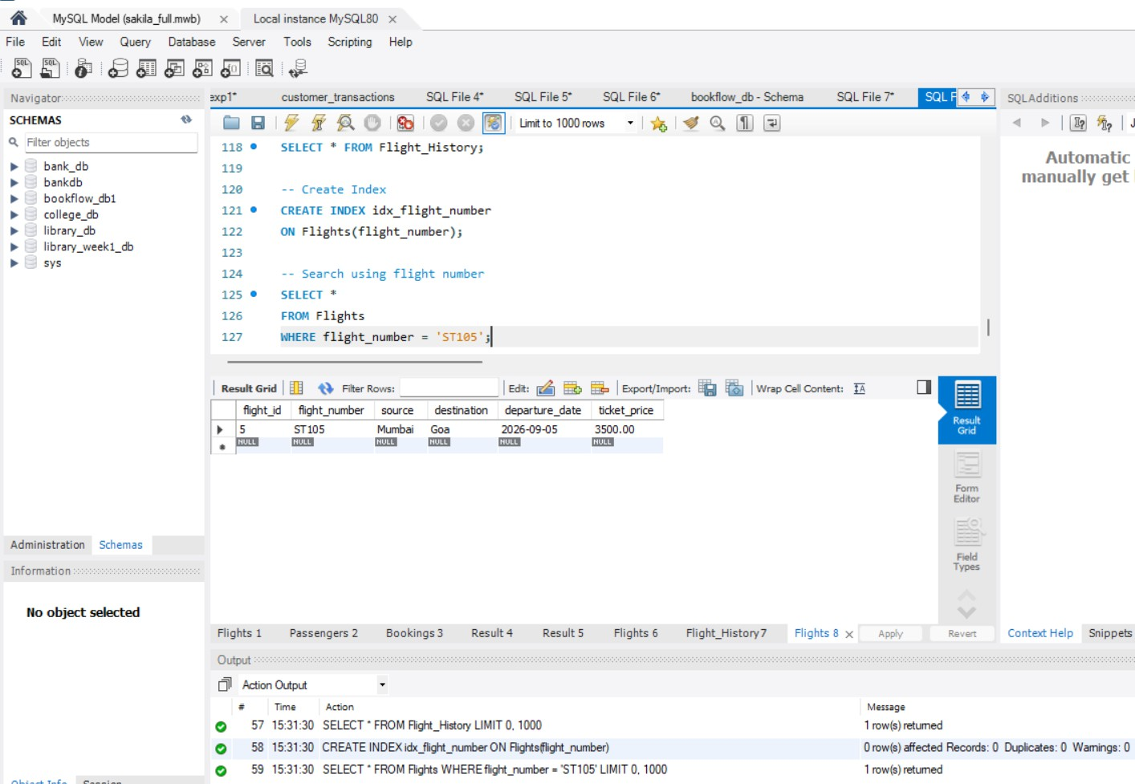
Problem Statement 2: MediCare Hospital Management System A hospital currently maintains patient records, doctor information, and appointment schedules manually, which often results in scheduling conflicts, misplaced records, and delays in accessing important information. To modernize its operations, the hospital wants to develop a database system called MediCare HMS. As a database developer, your task is to create a database named medicare_db and design three tables: Doctors, Patients, and Appointments. The Doctors table should store details such as doctor_id, doctor_name, specialization, and consultation_fee, while the Patients table should contain patient_id, patient_name, and email. The Appointments table should connect doctors and patients using foreign keys and include an appointment date. Apply appropriate constraints such as PRIMARY KEY, UNIQUE, and CHECK constraints to ensure data accuracy and consistency. Insert at least 10 records into each table. Display all table contents and write an SQL query using INNER JOIN to show the patient name, doctor name, specialization, and appointment date for all appointments. Generate a report displaying the number of doctors available in each specialization using COUNT() and GROUP BY. Create a Doctor_History table and demonstrate the use of a Transaction by registering a new doctor and

simultaneously recording the registration in the history table, ensuring both operations are completed successfully as a single unit. Finally, create an Index on the specialization column and explain how indexing improves search performance when locating doctors by specialization. This exercise helps students understand database design, table relationships, SQL queries, aggregate functions, transactions, and query optimization techniques.
output:
CREATE DATABASE medicare_db; USE medicare_db;

-- 1. Doctors Table CREATE TABLE Doctors (
doctor_id INT PRIMARY KEY, doctor_name VARCHAR(100) NOT NULL, specialization VARCHAR(100) NOT NULL,
consultation_fee DECIMAL(10,2) CHECK (consultation_fee > 0)
);

-- 2. Patients Table CREATE TABLE Patients (
patient_id INT PRIMARY KEY, patient_name VARCHAR(100) NOT NULL, email VARCHAR(100) UNIQUE NOT NULL
);

-- 3. Appointments Table CREATE TABLE Appointments (
appointment_id INT PRIMARY KEY, doctor_id INT NOT NULL, patient_id INT NOT NULL,
appointment_date DATE NOT NULL,
FOREIGN KEY (doctor_id) REFERENCES Doctors(doctor_id), FOREIGN KEY (patient_id) REFERENCES Patients(patient_id)
);

-- Insert 10 Doctors
INSERT INTO Doctors VALUES
(1, 'Dr. Rajesh Kumar', 'Cardiology', 1000),
(2, 'Dr. Priya Sharma', 'Neurology', 1200),
(3, 'Dr. Anil Reddy', 'Orthopedics', 900),
(4, 'Dr. Sneha Rao', 'Dermatology', 800),
(5, 'Dr. Vikram Singh', 'Cardiology', 1100),
(6, 'Dr. Ananya Das', 'Pediatrics', 700),
(7, 'Dr. Kiran Patel', 'Neurology', 1300),
(8, 'Dr. Meghana Devi', 'Orthopedics', 950),
(9, 'Dr. Rohit Verma', 'Dermatology', 850),
(10, 'Dr. Arjun Kumar', 'Pediatrics', 750);

-- Insert 10 Patients

INSERT INTO Patients VALUES
(1, 'Aarav Reddy', 'aarav@gmail.com'), (2, 'Diya Sharma', 'diya@gmail.com'), (3, 'Aditya Kumar', 'aditya@gmail.com'), (4, 'Ishita Rao', 'ishita@gmail.com'),
(5, 'Rohan Singh', 'rohan@gmail.com'), (6, 'Ananya Patel', 'ananya@gmail.com'), (7, 'Varun Das', 'varun@gmail.com'),
(8, 'Sneha Verma', 'sneha@gmail.com'), (9, 'Rahul Mehta', 'rahul@gmail.com'), (10, 'Pooja Devi', 'pooja@gmail.com');

-- Insert 10 Appointments
INSERT INTO Appointments VALUES (1, 1, 1, '2026-08-18'),
(2, 2, 2, '2026-08-18'),
(3, 3, 3, '2026-08-19'),
(4, 4, 4, '2026-08-19'),
(5, 5, 5, '2026-08-20'),
(6, 6, 6, '2026-08-20'),
(7, 7, 7, '2026-08-21'),
(8, 8, 8, '2026-08-21'),
(9, 9, 9, '2026-08-22'),
(10, 10, 10, '2026-08-22');

-- Display all tables SELECT * FROM Doctors; SELECT * FROM Patients;
SELECT * FROM Appointments;

-- INNER JOIN SELECT
p.patient_name, d.doctor_name, d.specialization, a.appointment_date
FROM Appointments a INNER JOIN Patients p
ON a.patient_id = p.patient_id INNER JOIN Doctors d
ON a.doctor_id = d.doctor_id;

-- Number of doctors in each specialization SELECT
specialization,
COUNT(*) AS number_of_doctors FROM Doctors
GROUP BY specialization;

-- Doctor History Table
CREATE TABLE Doctor_History (
history_id INT PRIMARY KEY AUTO_INCREMENT,
doctor_id INT NOT NULL,
doctor_name VARCHAR(100) NOT NULL, action VARCHAR(50) NOT NULL,
registration_date TIMESTAMP DEFAULT CURRENT_TIMESTAMP
);

-- Transaction
START TRANSACTION;

INSERT INTO Doctors VALUES
(11, 'Dr. Neha Kapoor', 'Cardiology', 1050);

INSERT INTO Doctor_History (doctor_id, doctor_name, action) VALUES
(11, 'Dr. Neha Kapoor', 'Doctor Registered');

COMMIT;

-- Verify transaction SELECT * FROM Doctors;
SELECT * FROM Doctor_History;

-- Create Index
CREATE INDEX idx_specialization ON Doctors(specialization);

-- Search doctors by specialization SELECT *
FROM Doctors
WHERE specialization = 'Cardiology';

